**CS5551-Advanced Software Engineering**

**Group 6 - Project Plan**

**Introduction:-**

With the increase in technology and globalization data is increasing day by day. Gathering required information from these huge volumes of available data is really difficult. Let us consider a scenario where a job seeker wants to search for a job based on his profile, requirements, income and location. In such cases he can extract the useful information from the available job search communities and technologies; it is really hard to figure out the right path from the available huge number of choices. In order to address such difficulties we designed an application that can provide the job lists matching the person based on his input criteria. Besides this the user can also figure out jobs in all aspects from high level to lower level in terms of category and income.

**Goals and objectives:-**

The application is designed for easy search of jobs for the job seekers based on the search criteria. It is free of cost and benefits mainly the job seekers who are searching for the jobs with low income and low skills and profile also. Sometimes applications and communities on line could not provide exact guidance to the job seekers with very low profile and seeking very low income. In this system the user can select the input parameters on wide range and get the fruitful result. The user can filter his search criteria based on the Zip code, industry, location and key words. The main goal of this application is to collect the data from the available job networking sites and then extract the useful information from it so that the user can easily understand it with very minimal knowledge. The user can change his priorities at any time he wishes to modify the criteria. There is an extra feature by which the user can also find the exact distance of the job location from his current location and planning to implement the means of transport. In this way the user can benefit with very low cost and search by various features.

**Proposed Systems:-**

Our system typically consists of a login page: Here the user logs in to the system. The user may be of two types both the registered user and the guest user is optional case. Each user has their own specific functionalities. In the initial phase there is a validation check provided for the users. First the lists of all the available jobs of all varieties are displayed based on the job seeker search specifications like Zip code, Salary etc... The user can see the full list and can make a clear view on the available suggestions. Besides this he also gets a mail or SMS confirmation when he applied for the particular position in a company. Here the advantage of our application is that it is free service and offers as a good guide for the job seekers who search even for low income and low skills. It may be a part time or a full time etc...There will be an employer login also. In this employer section he can add the jobs to the system and can delete the jobs from the system. He is similar to the administrator of the application. He can view all the applications submitted by the job seekers. Once the user gets registered he will be able to perform all the required tasks in the application like searching and applying for the job.

**Activity Diagram:-**

The below UML activity diagram clearly describes about the flow of the entire Process. It is explained clearly in the form of flow chart.

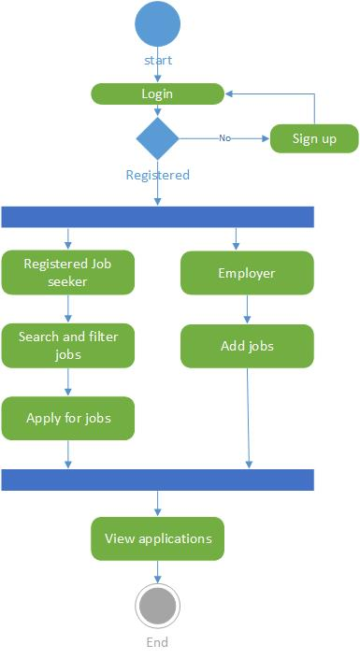

**System Architecture:-**

The primary components that are included in our system are GUI, existing web services and API’s. As we collect the data and records of some job search portals and career communities, we first parse the available large data and collect only useful information to the user so that he can understand it with minimal knowledge. We get the data in the form of xml or JSON from the existing data sources. Later this data is retrieved back to the user to the GUI based on the priorities he selects. There will be a data base to manage all these records and revert back the useful information.



**Software Specifications:-**

**Tools:** Android Development Kit, Microsoft Visual Studio 2010

**Operating System:** Android, Windows

**Development Operating System**: Windows 8

**Programming Languages:** Java 7.0, C#, ASP.NET

**Databases:** SQL 2008, SQLite

**Data Sources:-**

We are using the data and extracting the useful information from the existing communities, API’s and NY Labor departments.

1. <http://www.linkup.com/developers/>

2. <http://www.programmableweb.com/category/jobs/apis?category=20080>

3. <http://www.labor.ny.gov/jobs/regional.shtm>

4.[https://data.ny.gov/browse?Dataset- Information_Agency=Labor%2C+Department+of&utf8=%E2%9C%93](https://data.ny.gov/browse?Dataset-%20%20Information_Agency=Labor%2C+Department+of&utf8=%E2%9C%93)

**Class Diagram:-**

The following class diagram describes briefly about the various classes that we use in the system. It is basically an initial design of the system.

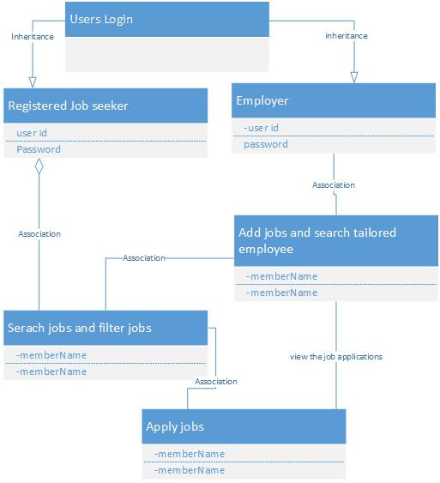

**Sequence Diagram:-**

The below sequence diagram helps in identifying all the sequence of operations and steps that takes place in the process from initial phase to the final phase.

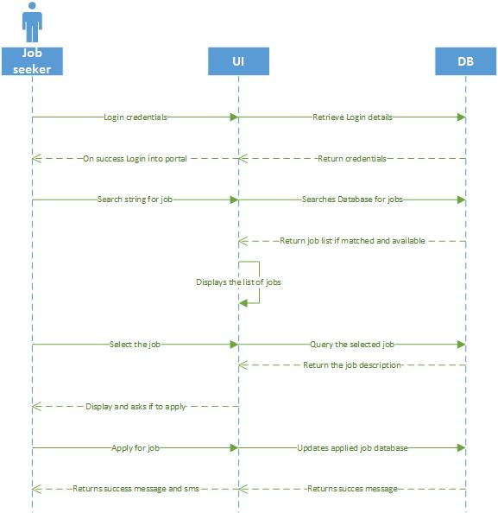

**Task Planning:-**

We develop our entire project life cycle using agile methodology where the progress of the project takes place in terms of iterations or phases.

Each and every phase consists of all the common phases of the life cycle as follows that includes development to testing.

1. Design of the User interface and collecting required data for it.

2. Data extraction from the available services and API’s

3. Analyzing the services according to our application development

4. Testing the application in each phase and fix the bugs if necessary.

The tool we use to maintain the records of all these tasks is ScrumDo. Entire process and progress can be accessed using this tool in the form of stories and Graphs.

<http://www.scrumdo.com/projects/project/job-amigo/summary>

We have designed the entire organization structure and project dash board in the above mentioned URL.

**People:-**

* Kommineni, Siva Krishna (ID-20)
* Thallapalli, Ravisha (ID-37)
* Bandaru, Sarath Chandra (ID-5)
* Yempalla, Suresh Reddy (ID-49)

**Bibliography:-**

The project Idea has been incorporated from Big Apps NYC 2014 challenge

1. <http://realtimejobdata.splashthat.com/>

2. <http://bigapps2014.splashthat.com/>

3. <http://en.wikipedia.org/wiki/Web_application_development>

4. <https://www.google.com/>